1. *n* = 25*, p* = 10*, sima* = 3

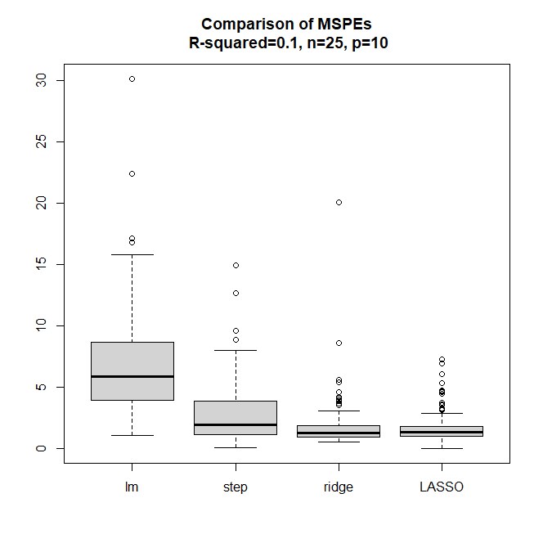

* Lasso seems to be best in this setting

1. *n* = 500*, p* = 10*, sima* = 3

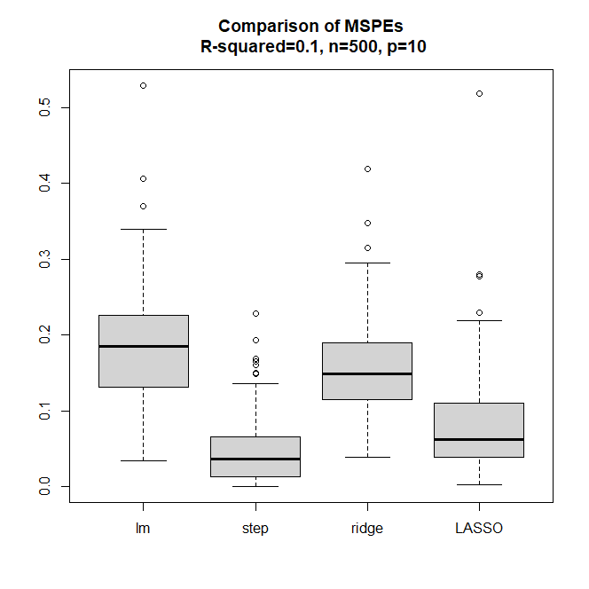

* Stepwise seems to be best in this setting

1. *n* = 50*, p* = 2*, sima* = 3

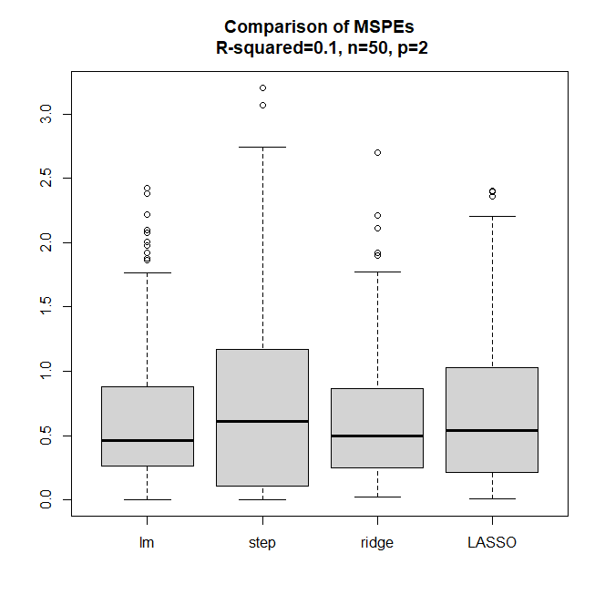

* Ridge seems to be best in this setting

1. *n* = 50*, p* = 30*, sima* = 3

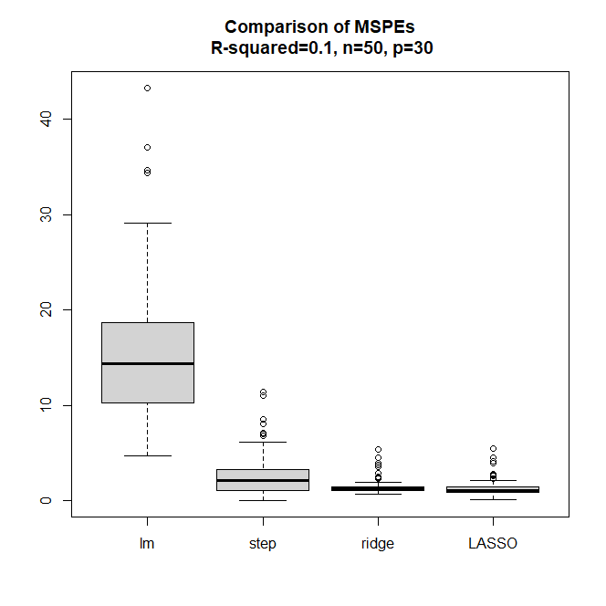

* Ridge and LASSO looks similar, bur ridge seems to be slightly better than LASSO in this setting.

1. *n* = 50*, p* = 10*, sima* = 0.5

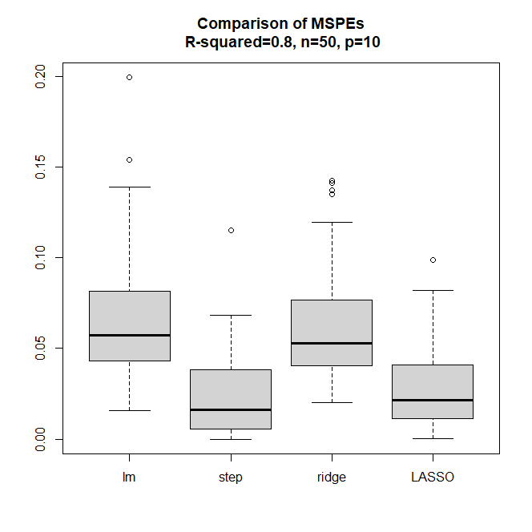

* Step seems to be best method in this function

1. *n* = 500*, p* = 100*, sima* = 3

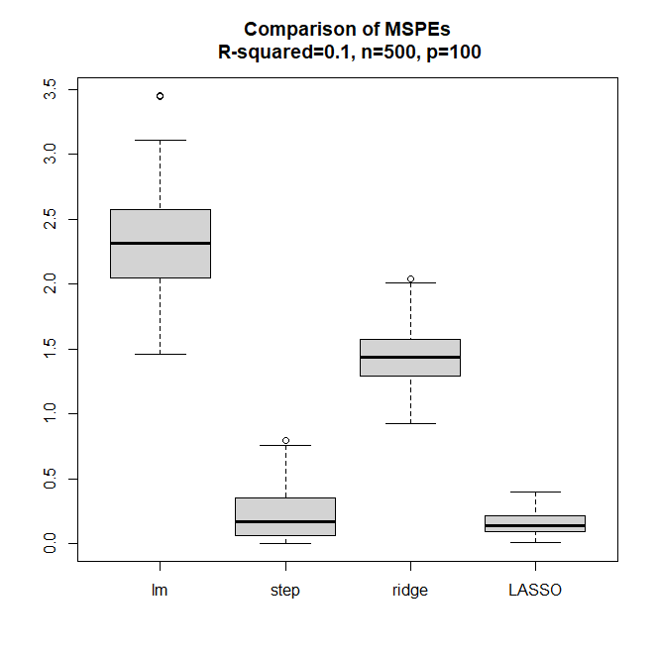

-> Lasso seems to be best in this setting

7. *n* = 500*, p* = 2*, sima* = 0.5

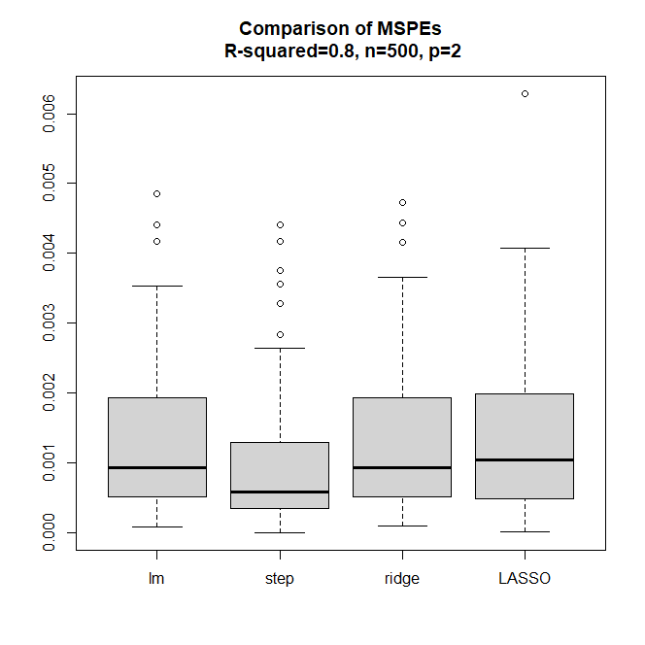

* Step seems to be best in this setting